Incivility and Job Turnover in Newly Licensed Registered Nurses
Sarah Garcia-Portillo MSN-Ed, BSN, RN sgportillo@utexas.edu
https://nursing.utexas.edu/academics/graduate/degree-offered/dnp
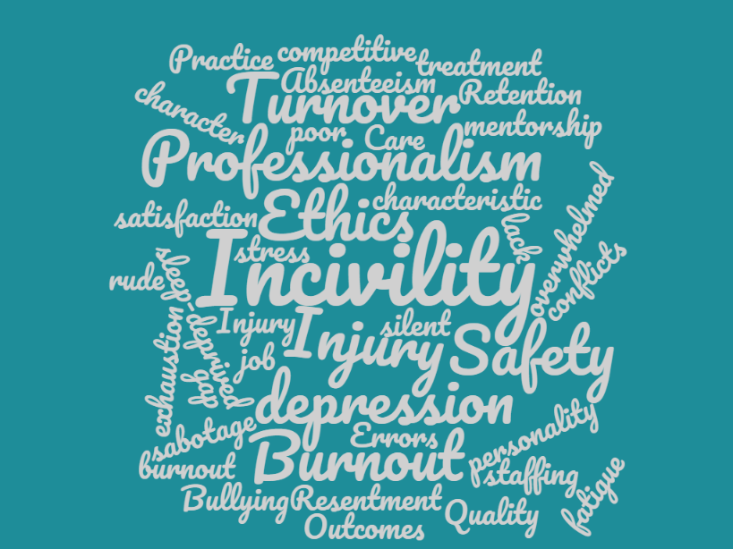

Incivility, bullying, and workplace violence are part of a larger complex phenomenon, which includes a “constellation of harmful actions taken and those not taken” in the workplace (Saltzberg, 2011, p. 229).

References:
American Association of Colleges of Nursing. (2015). 2014–2015 Enrollment and Graduations in Baccalaureate and Graduate Programs in Nursing. Retrieved from http://www.aacn.nche.edu/research-data.
Brewer, C. S., Kovner, C. T., Greene, W., Tukov‐Shuser, M., & Djukic, M. (2012). Predictors of actual turnover in a national sample of newly licensed registered nurses employed in hospitals. Journal of advanced nursing, 68(3), 521-538.
Brunworth, J. A. (2015). Eating our young in nursing... Are we full yet. Retrieved from https://www.elsevier.com/connect/eating-our-young-in-nursing-are-we-full-yet
McAfee, T. (2019) Reducing turnover, increasing retention. HRO Today. Retrieved from https://www.hrotoday.com/news/talent-acquisition/healthcare-workforce/reducing-turnover-increasing-retention/
Nursing Solutions, Inc. (2019) 2019 National Health Care Retention & Staffing Report. Retrieved from
Rogers, A. E. (2008). The effects of fatigue and sleepiness on nurse performance and patient safety. In Patient safety and quality: An evidence-based handbook for nurses. Agency for Healthcare Research and Quality (US).
Sears, L. E., Shi, Y., Coberley, C. R., & Pope, J. E. (2013). Overall well-being as a predictor of health care, productivity, and retention outcomes in a large employer. Population Health Management, 16(6), 397-405.
The Joint Commission [TJC].(2012) Improving patient and worker safety: Opportunities for synergy, collaboration and innovation. Retrieved from https://www.jointcommission.org/assets/1/18/TJC-ImprovingPatientAndWorkerSafety-Monograph.pdf
Zhu, Z., Xing, W., Lizarondo, L., Guo, M., & Hu, Y. (2019). Nursing students’ experiences with faculty incivility in the clinical education context: a qualitative systematic review and meta-synthesis. BMJ open, 9(2), e024383.

